​​Southminster United Church, Ottawa, Ontario
August 9, 2026
Eleventh after Pentecost

Worship Leader: Rev. Susan Toller
Director of Music: Sarah Westbrook
Reader:

Prelude:
Welcome
Land Acknowledgement
We acknowledge we are gathering on the unceded land of the Algonquin Anishinaabe people. They have cared for this land for millenia.
The National Indigenous Spiritual Gathering (NISG) 2026, for the United Church, Mino Biidaabin—Our New Day—On Kion Niserase was held July 15-19. The gathering included several days of worship, ceremony, learning, discernment, and community-building on traditional Algonquin Territory, at Carleton University in Ottawa. The gathering brought together Indigenous leaders, Elders, youth, ministers, and community members from across The United Church of Canada to strengthen relationships, celebrate Indigenous spiritual leadership, and continue the journey toward a self-determining Indigenous Church.
A significant milestone of the gathering was the covenanting and affirmation of the National Indigenous Council (NIC). The council will play a central role in helping shape the future of the autonomous Indigenous Church, and guiding its work in the years ahead. Participants engaged in workshops and learning opportunities on topics including Indigenous approaches to palliative care, climate justice, and Indigenous leadership ahead of COP30, as well as global ecumenical relationships through the World Council of Churches, and the ongoing work of the Sandy-Saulteaux Spiritual Centre.
Let’s be grateful for the work of the new National Indigenous Council and the important insights it will bring to Indigenous people and the United Church of Canada.
Lighting of the Candles
Long ago, Jesus called some unlikely fisher folk and an ostracized tax collector to follow him. In the same manner, Jesus called a surprised woman to draw water for him and then become a disciple.
Today, Jesus is calling us to be light in a shadowed world. We light this candle as a reminder that we are people of the Way of Jesus!
Laura J. Turnbull, Penticton, B.C.
We light the Affirming candle to remind us that everyone is welcome here. We hope this holy space provides comfort for people of all cultural backgrounds, physical and mental abilities, sexual orientations and gender identities. God loves all of us.
Opening Prayer
Creator God, open our hearts today to feel your presence, to receive your words, to sing your praises, to trust in your promises, and to find the grace and peace that you are offering to every one of us as we respond to you. On this holy day, we remember that you have invited us into a covenant and a calling, and that you have invited us to live in the ways of your precious kingdom, even as you remind us that we are part of everything that you do. On this holy day, we will answer your call to a life of faith.
We will answer your call to be attentive to people we meet along the way.
We will answer your call to recognize the blessings you provide. We will answer your call to care for the whole earth and everyone in it. We will answer your call. Thanks be to God. Amen.
Julie Hutton, Minnedosa U.C., Minnedosa, Man.
Opening Hymn: Dance with the Spirit (MV 156)
Scripture Reading
Genesis 12:1-9
Now the Lord said to Abram, “Go from your country and your kindred and your father’s house to the land that I will show you. I will make of you a great nation, and I will bless you and make your name great, so that you will be a blessing. I will bless those who bless you, and the one who curses you I will curse, and in you all the families of the earth shall be blessed.”
So Abram went, as the Lord had told him, and Lot went with him. Abram was seventy-five years old when he departed from Haran. Abram took his wife Sarai and his brother’s son Lot and all the possessions that they had gathered and the persons whom they had acquired in Haran, and they set forth to go to the land of Canaan. When they had come to the land of Canaan, Abram passed through the land to the place at Shechem, to the oak of Moreh. At that time the Canaanites were in the land. Then the Lord appeared to Abram and said, “To your offspring I will give this land.” So he built there an altar to the Lord, who had appeared to him. From there he moved on to the hill country on the east of Bethel and pitched his tent, with Bethel on the west and Ai on the east, and there he built an altar to the Lord and invoked the name of the Lord. And Abram journeyed on by stages toward the Negeb.
Herein is Wisdom.
Thanks be to God.
Matthew 9: 9-13
As Jesus was walking along, he saw a man called Matthew sitting at the tax-collection station, and he said to him, “Follow me.” And he got up and followed him.
And as he sat at dinner in the house, many tax collectors and sinners came and were sitting[ with Jesus and his disciples. When the Pharisees saw this, they said to his disciples, “Why does your teacher eat with tax collectors and sinners?” But when he heard this, he said, “Those who are well have no need of a physician, but those who are sick. Go and learn what this means, ‘I desire mercy, not sacrifice.’ For I have not come to call the righteous but sinners.”
Herein is Good News.
Thanks be to God.
Gift of Music: On Holy Ground - As recorded by Barbara Streisand, written by Geron Davis Keri Hugh (soloist)
Reflection on God’s Calling
Hymn: I Have Called You by Your Name (MV 161)

Invitation of Offering
Our selves, our actions, our words, our mission, and our souls— we dedicate them all to you, O God, as we answer your call. Bless us and our gifts for your service that we may declare our faith by our cheerful giving back. Amen.
Gord Dunbar, Kincardine, Ont.
Presentation of the Offering: Blest be the Tie that Binds
(VU 602 v.1,3,4)
Offering Prayer
Holy Giver, you have given all that you are, to bring us life and to bring us into relationship with you and with one another.
We give you now of ourselves and our gifts to use to spread your words of truth, life, and love. We are grateful for you, for one another, for our families and friends, and for this world you love so much. Amen!
Susan Girard, Riverview U.C., Atikokan, Ont.
Prayers of the People
[share prayers of joy and concern with others]
(Sung Response): Lord Listen to Your Children Praying (VU 400)
The Lord’s Prayer
Our Mother and Father in heaven,
Hallowed be your name.
Your kin-dom come,
your will be done
On earth as it is in heaven.
Give us today our daily bread.
Forgive us our sins, as we forgive
those who sin against us.
Save us from the time of trial,
And deliver us from evil.

For the kingdom, the power,
and the glory are yours,
now and forever, Amen.
Announcements
Closing Hymn: Go Make a Diff’rence (MV 209)
Commissioning: When You Walk from Here (VU 298)
Postlude:
Coffee Time
Scripture readings are from the New Revised Standard Version (Updated Edition) of the Bible.
This service was mostly created by Gathering Worship Resource, Bree MacKenzie and Brooke MacKenzie and Lorna Carley, St. John’s United Church, Kemptville, Ont. Used with permission. The United Church of Canada.

Coffee Host: Bernie Ducker
Ushers/Counters: Heather Macfaden / Margaret Isaac

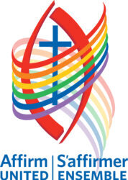
As the people of Southminster United Church, we affirm and actively support the life experience of all. All persons are invited to take part in every aspect of church life including membership, leadership, celebration of life passages and marriage. We are committed to following Jesus‘ example as we embrace people of all ages, racialized groups, genders, sexual orientations, gender identities, ethnic origins, economic circumstances and differing abilities and challenges in the ministry and life of Southminster United Church.

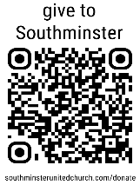
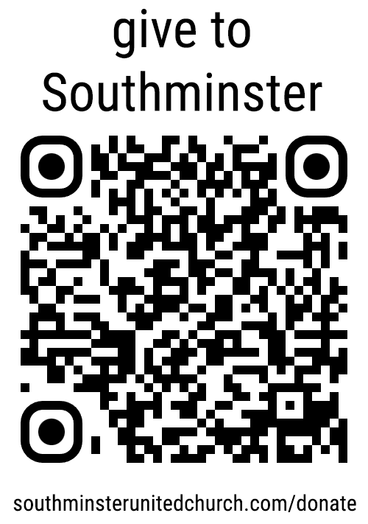
Make a DONATION
Please consider making a donation to assist the operation and mission of the church. This QR code will take you to the donation page on our website or visit southminsterunitedchurch.com/donate

Southminster United Church / 15 Aylmer Ave. Ottawa ON K1S 3X1
613-730-6874 /admin@southminsterunitedchurch.com / southminsterunitedchurch.com

